**Excel Assignment - 18**

**1. What are comments and what is the importance if commenting in any**

**code?**

A VBA COMMENT is a green line of text that helps you to describe the written code. In simple words, a comment is a line of text which is not a code and VBA ignores it while executing the code

Use of comment in our code help us in following ways

1. Helps us Document our work
2. Track the Changes
3. Describe a Function Procedure
4. Describe a Variable
5. Debug Code

**2. What is Call Statement and when do you use this statement?**

The CALL statement is use to transfers control from one object program to another within the run unit.

When you have more than one subroutine, you can pass execution to a different subroutine by placing the name of the subroutine on a new line and prefix the name of the subroutine with the Call keyword

Sub Procedure_one()

Call Procedure_Two()

End Sub

The program containing the CALL statement is the calling program; the program identified in the CALL statement is the called subprogram

**3. How do you compile a code in VBA? What are some of the problem that**

**you might face when you don’t compile a code?**

Debug Menu -> Compile VBA Project

Below are some of the problems we may face, if we don’t compile our VBA code.

* Undeclared Variables.
* Undeclared Procedures.
* Incorrect Coding – Expected End of Statement.
* Missing References.

**4. What are hot keys in VBA? How can you create your own hot keys?**

A hot key is a key or a combination of keys on a computer keyboard that, when pressed at one time, performs a task (such as starting an application) more quickly than by using a mouse or other input device. Hot keys are sometimes called shortcut keys.

In excel, hot keys are mostly used to context of macros. When we create a macros through Record Macros option in the Developer tab, in the Record Macro dialogue box, we get the option of assigning a shortcut or hot key to our macro. It generally of the form “Ctrl + __”.

**5. Create a macro and shortcut key to find the square root of the following**

**numbers 665, 89, 72, 86, 48, 32, 569, 7521**

1. Create the data in excel worksheet

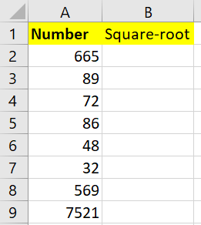

1. Go to Developer > Record Macro -> In the Record Macro dialogue box

Fill the below details given in the figure

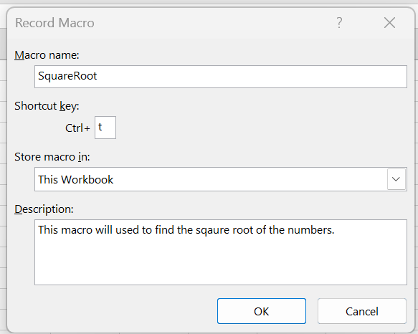

1. Quickly use the below Formula for the first number and use flash fill options to calculate square root of all the numbers.

=SQRT(A2)

1. Go to Developer tab -> Stop Recording

Now, we have a macro name ‘SquareRoot’ with Shortcut ‘Ctrl + t’ which will calculate square-root of the number present in the range A2:A9 when Ctrl + t is pressed.

**6. What are the shortcut keys used to**

**a. Run the code : F5**

**b. Step into the code : F8**

**c. Step out of code: Ctrl + Shift + F8**

**d. Reset the code :Alt + R+ R**